1. Engineers must consider the breadths of male heads when designing motorcycle helmets for

men. Men have head breadths that are normally distributed with a mean of 6.0 inches and a

standard deviation of 1.0 inch

a. If one male is randomly selected, what is the likelihood that his head breadth is less than

6.2 inches?

b. b. The Safeguard Helmet company plans an initial production run of 100 helmets. How

likely is it that 100 randomly selected men have a mean head breath of less than 6.2

inches?

c. The production manager sees the result in part b and reasons that all helmets should be

made for men with head breadths of less than 6.2 inches, because they would fit all but

a few men. What is wrong with that reasoning?

**Solution # 1**

Given Mean, µ = 6, SD, σ = 1.0

1. z- score , z = (x-µ)/σ = (6.2-6)/1=0.2

p (x<6.2)

=p(z<0.2)

= 0.5+0.793

=0.5793

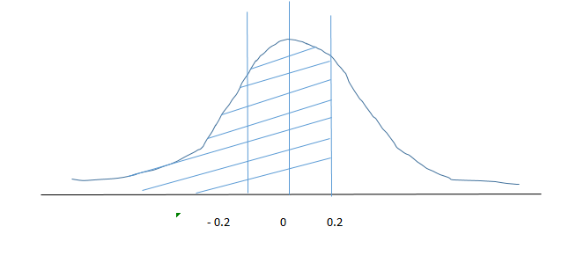

1. n = 100 , µ = 6 , σ = 1.0

Standard Error σ* = σ / sqrt(n) = 1/10=0.1

z- score , z* = (x-µ)/σ* = (6.2-6)/0.1=2

p (x<6.2)

=p(z*<2.0) =0.5+0.4772=0.9772

1. Probabilities concerning means don’t apply to individuals, part (a) is relevant since the helmets will be worn by one man at a time.

P(an individual has a head breath greater than 6.2)

=1-0.5793=0.42

So 42% of man would not find a helmet that’s fits

2. Suppose the mean weight of King Penguins found in an Antarctic colony last year was 15.4 kg.In a sample of 35 penguins same time this year in the same colony, the mean penguin weight is 14.6 kg. Assume the population standard deviation is 2.5 kg. At .05 significance level, can we

reject the null hypothesis that the mean penguin weight does not differ from last year?

**Solution # 2**

The null hypothesis is that μ = 15.4

Sample mean = 14.6

Hypothesized value = 15.4

population standard deviation σ = 2.5

Sample size , n = 35

Standard Error σ* = σ / sqrt(n)

z- score , z* = (x-µ)/σ* = -1.893

Critical values at .05 significance level, α = 0.05

|  |  |  |  |
| --- | --- | --- | --- |
| Level of significance | 1% | 5% | 10% |
| z critical value for one tailed test | +2.33 or -2.33 | +1.645 or -1.645 | +1.28 or -1.28 |
| z critical value for two tailed test | +2.58 and -2.58 | +1.96 and -1.96 | +1.645 and -1.645 |

The test statistic z* -1.8931 lies between the critical values -1.9600 and 1.9600. Hence, at .05 significance level, we do not reject the null hypothesis that the mean penguin weight does not differ from last year.